EE447 Term Project Final Report

Erçetin Kuyucu 2094241

Mehmet Ali Açıkbaş 2030245

### **Introduction**

In this project, we have designed and implemented a system which includes a basic sound recorder with a speaker in order to play the audio record with desired frequencies. Our main component is TM4C123GXL board, which was used in EE447 course laboratories previously. Audio recorder and player are triggered by push buttons of the board. Sound waves are sampled with GPIO and converted to digital signals by using ADC. The play frequency is varied between 2 kHz and 10 kHz. Samples are converted to corresponding voltage values by a DAC. The communication between the microprocessor and DAC is utilized with I2C protocol. The required power for speaker is supplied by an amplifier. It amplifies the sound signal power up to 2.5 Watts. A speaker converts voltage to sound waves.

### **Block Diagram**



Figure 1: Block diagram of system

### **State Diagram**



Figure 2: State diagram of system

### **Hardware Scheme and PIN Assignments**

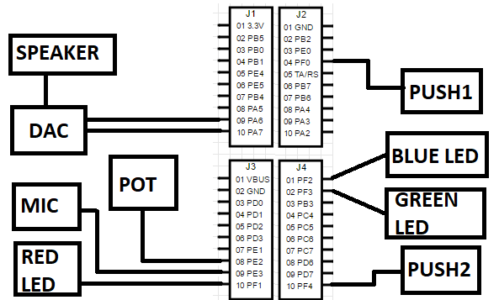

Figure 3: Hardware Scheme and Pin Assignments

1. **Workload Chart**

Workload chart can be seen in Figure 4. Erçetin contributed to project more than M. Ali and we do not share the work categorically so that we could check each other’s work.

|  |  |  |
| --- | --- | --- |
|  | Erçetin Kuyucu | M. Ali Açıkbaş |
| Research | **XX** | **X** |
| Coding | **XX** | **X** |
| Test Protocols | **XX** | **X** |
| Documentation | **XX** | **X** |

Figure 4: Workload Chart of Group Members

### **Sub-Modules**

#### Microphone

#### In the project the MAX9814 is used.The MAX9814 is a low-cost, high-quality microphone amplifier with automatic gain control (AGC) and low-noise microphone bias. Due to these features this microphone is preferred. It converts sound waves to electrical signal. It’s output is directly connected to microcontroller on PE3 pin.

#### Microcontroller

In the project TM4C123GXL board is used. It consists of a TM4C123GH6PM microcontroller. The GPIO, ADC, timer, I2C features of TM4CGH6PM is used.

#### ADC

TM4C123GH6PM has 2 ADC cores with 10 input pins. It converts signals to 12 bit samples. Internal FIFO memory holds the samples after conversion. It can get samples up to 1 million samples per second. The trigger of the ADC can be software, timers, analog comparators or GPIO. In the project ADC0 is used for converting electrical sound signals to 12 bit numbers. However, we shifted logically the data 4 times so that we reduces noise and simplify the data operations since 8 bit=1byte is more eligible for some operations. Also the play rate of the sound is varied with an potentiometer. The output of the potentiometer is sampled by ADC1 in order to change the play rate. Potentiometer output varies between 0 and 3.3 Volts. Note that frequency varies between 2 kHz and 10 kHz since these interval can be heard by human ears.

#### SRAM Memory

TM4C123GH6PM has a 32 kilobyte user accessible SRAM Memory. The samples get from ADC are stored at the SRAM memory until the playing of the sound. A sample is roughly a 1.5 byte. If a 8 kilo sample per second rate is used at ADC the recording data rate makes 12 kilobyte per second. If 32 kB memory is available at the microcontroller this means roughly a 3 second recording can be made.

* + 1. Timer

TM4C123GH6PM has 6 general purpose timers. These timers can be configured as 16 bit or 32 bit. The timers are used in the project for triggering I2C communication and triggering ADC operation for sampling of sound signals. In the requirements the sampling rate is stated as 8 kHz thus the timer is set accordingly as periodic when recording is triggered. Also the play rate is stated as 2-10 kHz in the requirements thus the timer for triggering I2C communication is set between 2-10 kHz according to the reading from ADC. This timer triggered when the recording finishes as periodic.

#### I2C

TM4C123GH6PM has 3 I2C drivers which utilizes varying pins. I2C driver of the microcontroller has the capability of transmitting data up to 3.3 Mbps at the high speed mode. In the project, microcontroller used as master in the communication. The samples which are obtained from ADCs are sent to DAC by using I2C. Configuration details and comments can be found in code file.

#### Push Buttons

We have two push buttons on TM4C123GH6PM which are used to start recording and playing operations. Push Button1 (SW1) is used for recording and Push Button2 (SW2) is used for playing. Note that PF0, which is used for SW2, is locked by default. Therefore, we needed to unlock it by software.

#### LEDs

We show operation states (idle, record, play) by using LEDs which are already existed on the TM4C123GH6PM. As stated in the project manual, we assigned blue led as idle mode, red led as record mode and green led as play mode. PF1, PF2, PF3 pins are used for this operation.

#### DAC

MCP4725 is a 12 bit DAC with I2C interface. It receives data through I2C protocol up to 3 Mbps. It has non-volatile EEPROM for control registers. It converts 12 bit data to a voltage between VCC-0 V. DAC used for playing the sound.

#### Amplifier

In the project PAM8302A is used as amplifier. It has capability of providing 2.5W power for speaker circuitry. By the help of the amplifier, required current for driving the speaker is supplied.

#### Capacitors

Two capacitors are added to setup to eliminate noise of ambient. These capacitors function as low-pass filters. Capacitor values are chosen as 1 uF which is sufficient to fulfill the filtering requirement.

#### Speaker

A 2.5 W 8 ohm speaker is used as sound converter. In order to convert output voltage to sound waves this module is used.

### **Conclusion**

As observed the project consists of hardware and software parts, software parts includes the initialization of microcontroller and from the trigger to the end operation control of the hardware. The user programmable memory is only capable of 32 kbyte of data. This was a strict restriction on recording time. The ARM Cortex M4 instruction set is used in order to program the microcontroller. The hardware parts includes the DAC, amplifier and microphone boost circuitry. The microphone circuitry has the sound input and the analog voltage output while the DAC has the I2C protocol input and the analog signal output. The amplifier circuitry has both analog input and outputs. We searched on datasheets and manuals to overcome problems and internet search was also beneficial at some points. In general, we solved problems quickly thanks to our experiences from microprocessors laboratories. The overall setup can be seen in Figure 5.

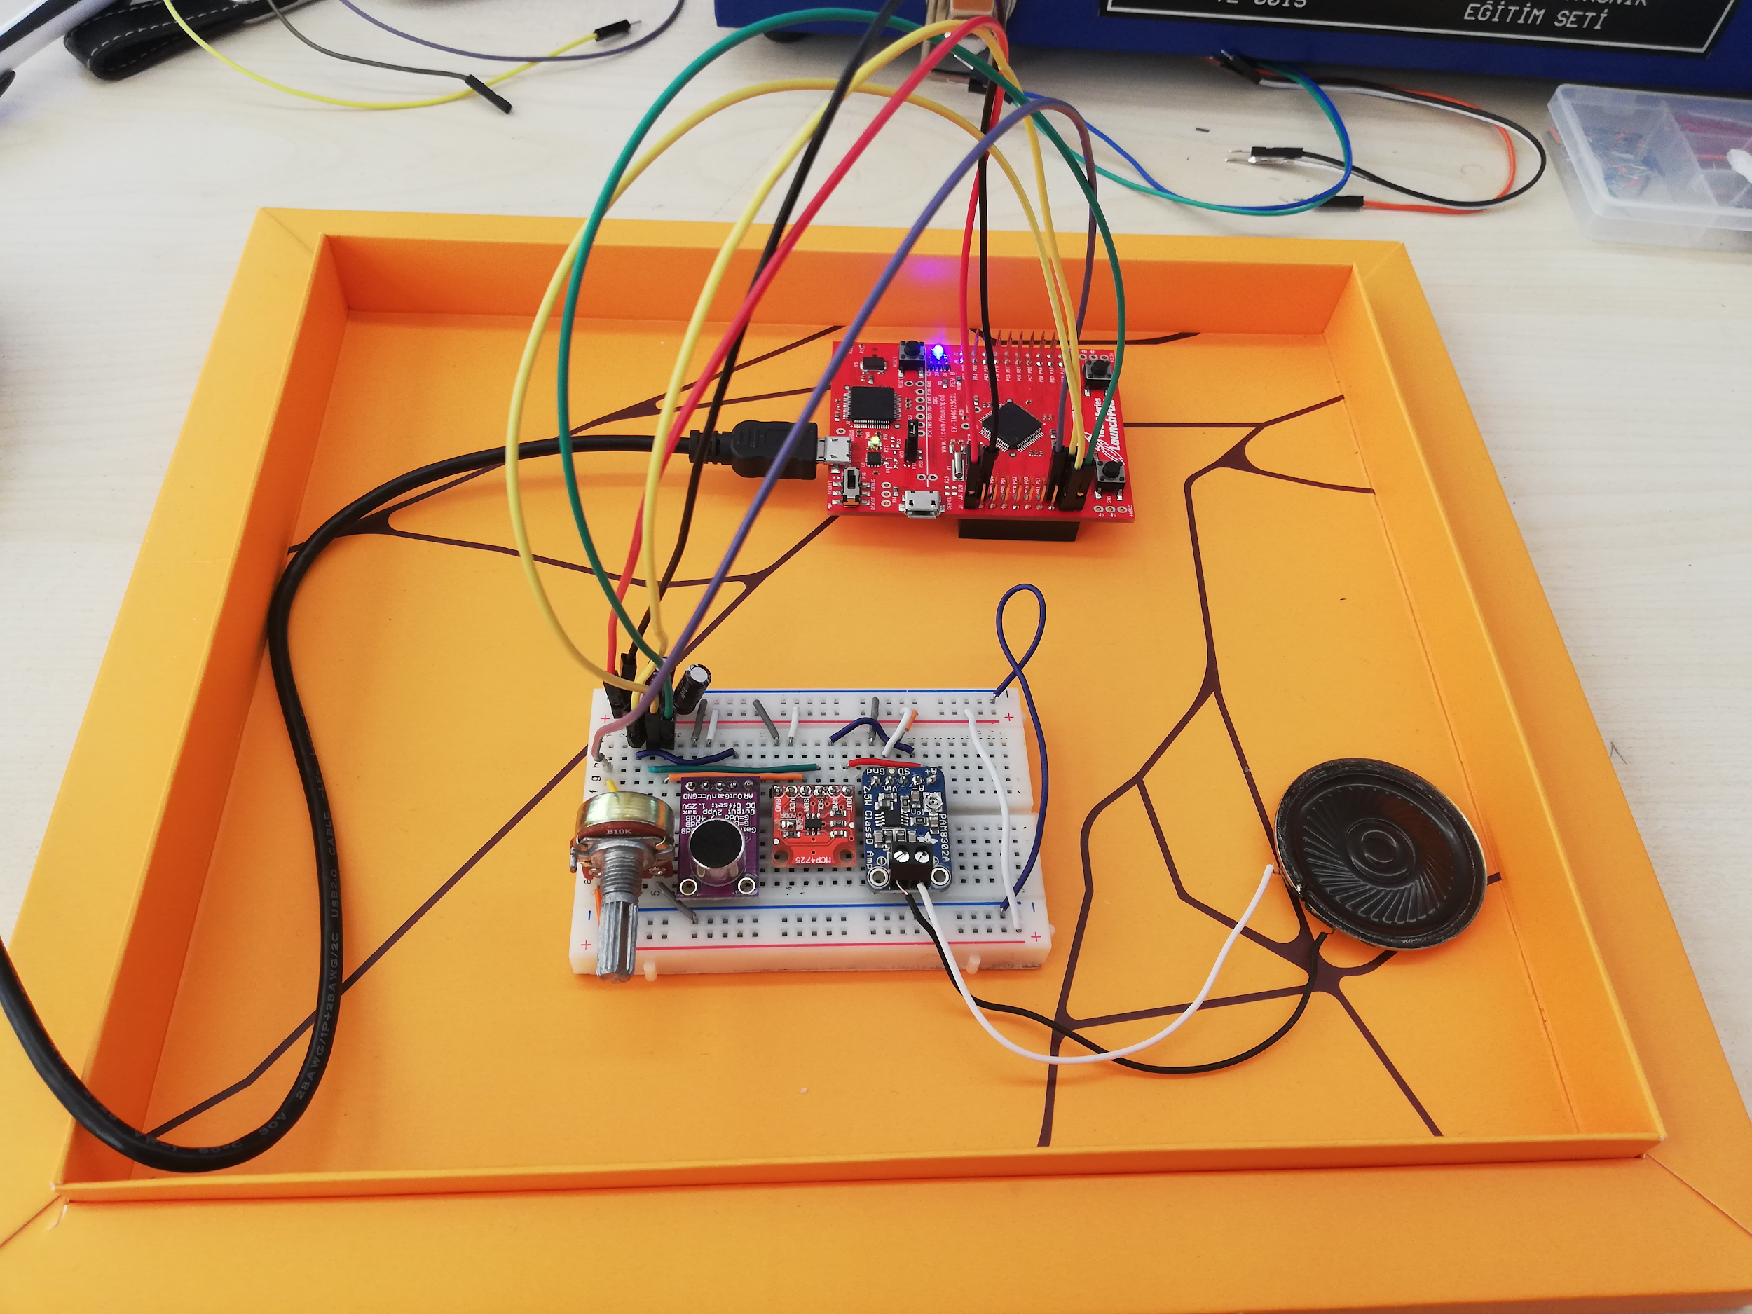

Figure 5: Overall Setup